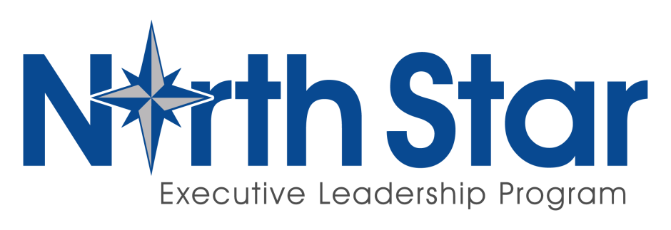

Session: 2020 Dates: TBD

Location: TBD

Price: $3,480.00 USD

-----------------------------------

Applicant Information

First Name

Last Name

Job Title Rank

Are you a sworn officer?

How many years have you been in law enforcement?

How many employees are in your agency?

How many individuals do you supervise either directly or indirectly?

Work Phone Mobile Phone

Email

Organization Name

Organization’s Chief Executive (e.g. Chief, Sheriff)

Name and Title to whom you report

Organization Address (Street)

(City, State, Zip)

High School/Year Graduated

Undergraduate College/Degree/Year Graduated

Graduate or Professional School/Degree/Year Graduated

How did you learn about North Star?

- Please feel free to attach your resume or CV. Documentation speaking to the positions you have held and the accomplishments you have had during your career are helpful to the selection committee.

- Once your application is complete with both signatures, please email the application to registration@cpleinternational.org. You will be notified of your application status usually within 48 hours.

- Upon acceptance to North Star, please select the REGISTER NOW button on our website. Our secure, online registration process allows for easy registration. Simply choose the session you were selected to attend, provide your contact information, and select your form of payment. You will receive a confirmation email upon completion of the registration.
Applicant: North Star is a demanding program requiring commitment and hard work throughout the four weeks. Keeping up your readings and assignments is essential beginning with pre-work before you arrive. The curriculum is rigorous, but more importantly, your engagement contributes to the success of every other North Star participant. By signing this application, you acknowledge and agree to these expectations.

_______________________________ _______________
Applicant Signature Date

Agency Approving Official: By signing below, you acknowledge your agency has approved the applicant’s attendance. You also affirm full funding has been approved and payment will be received by the CPLE International by May 12, 2017.

_______________________________ _______________________________
Agency Approving Official Agency Approving Official
Printed Name Signature

_________________
Date

- Please note the North Star fee includes instruction, books, materials, program activities and events, lodging and meals for the duration of the program. Tuition does not include travel expenses. As lodging and classrooms are financially committed to months prior to the event, refunds cannot be given. However, alternate qualified personnel from the nominee’s department may replace a previously accepted applicant.

